**Home.js**

import React, { Component } from "react";

export default class Home extends Component {

    render() {

        return (

            <div>

                <h3>Welcome to the Home Page of Student Management Portal</h3>

            </div>

        )

    }

}

**About.js**

import React, { Component } from "react";

export default class About extends Component {

    render() {

        return (

            <div>

                <h3>Welcome to the About Page of Student Management Portal</h3>

            </div>

        )

    }

}

**Contact.js**

import React, { Component } from "react";

export default class Contact extends Component {

    render() {

        return (

            <div>

                <h3>Welcome to the Contact Page of Student Management Portal</h3>

            </div>

        )

    }

}

**App.js**

import Home from './Components/Home.js';

import About from './Components/About.js';

import Contact from './Components/Contact.js';

import './App.css';

function App() {

  return (

    <div className="App">

      <Home />

      <About />

      <Contact />

    </div>

  );

}

export default App;

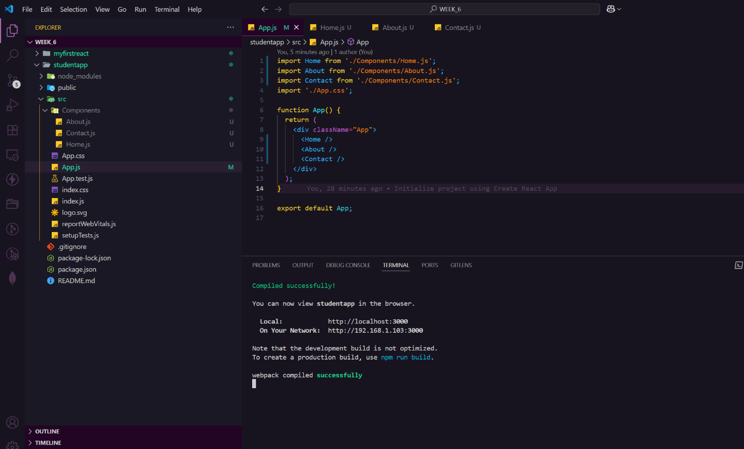

**OUTPUT:**

